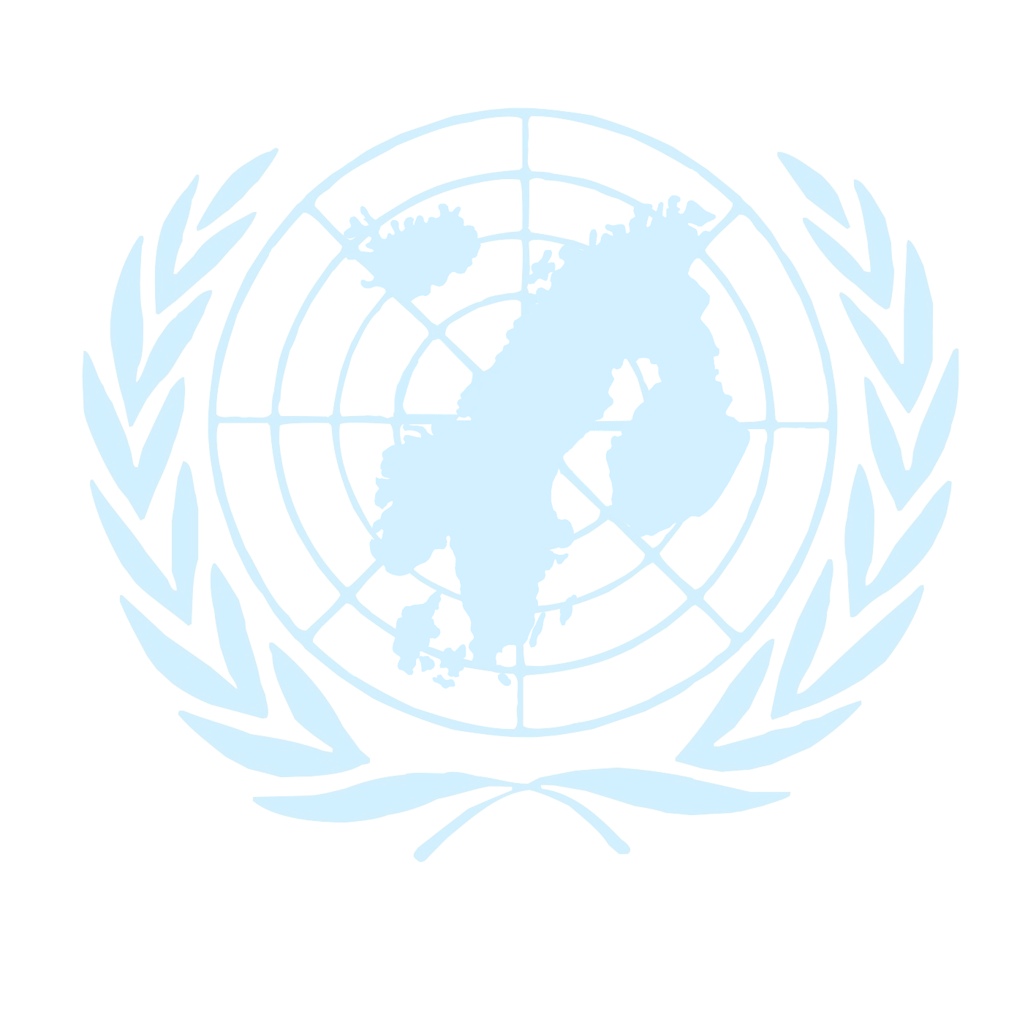
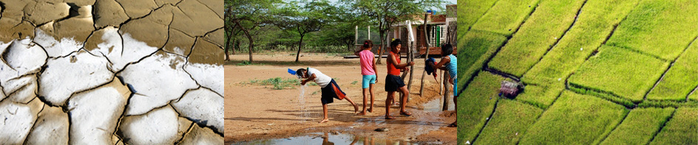
Nordic MUN 2012
Youth Climate Change Model United Nations Conference

Nurmijärvi, Finland
April 23-26, 2012

”Climate change is real, it is accelerating and it threatens all of us. We must respond with urgent action to stabilize the climate, achieve the Millennium Development Goals, and encourage individual action.”

- Ban Ki-moon

It’s time to make a change!

A student in higher education, under 30 years of age and interested in the climate issue?
We welcome you to debate the biggest issue of our lifetime, our survival on Planet Earth, as a part of an enthusiastic group of 200 young people from the Nordic and Baltic Countries
Preliminary Agenda for Nordic MUN 2012 (Security Council):
April 23 Arrival in Kiljavanranta, Nurmijärvi (Finland)
Nordic MUN 2012 Opening Ceremony
Lobbying starts
April 24 Rules of Procedure
Security Council simulation starts
Discussion on an issue concerning international peace and security in relation to the climate change
Negotiations on draft resolutions
April 25 Security Council simulation continues
Resolution writing
A fun evening with sauna, games and more!
April 26 Check-out from venue
Travelling back home /
April 27 Voluntary Post Nordic MUN 2012 events in Helsinki (tbc)
We look forward to your application to Nordic MUN 2012 if you:
- are a student in tertiary education (university or equivalent)
- are interested in different aspects of the climate change question
- can use English as a working language, both oral and written
- come from one of the Nordic or Baltic countries or is currently an exchange student in one of these

Submit your application before 31st of January 2012 at www.nordicmun.com
Delegation Fee 75 € / person (includes accommodation with full board)
Conference venue and accommodation: Kiljavanranta, Nurmijärvi (Finland)
Organizers: The UN Associations in Finland, Sweden and Norway in cooperation with Finnish Model United Nations (FinMUN)
For more information about Nordic MUN 2012, contact Tuija Sarvi (in English): tuija.sarvi(at)ykliitto.fi . For more information about the Security Council in particular, contact Antonia Westerholm: antonia.westerholm(at)finmun.org.
