

**Call for PhD Project proposals: The Development of Roads and Transport Infrastructure in the Hinterland of Rome**

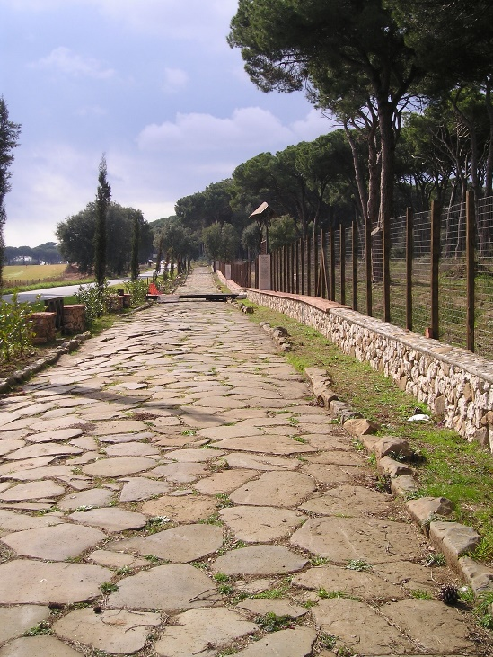As part of a collaboration between the [Universities of Macquarie (Sydney, Australia)](https://www.mq.edu.au/faculty-of-arts/departments-and-schools/department-of-history-and-archaeology) and [Groningen (The Netherlands)](https://www.rug.nl/research/groningen-institute-of-archaeology/?lang=en) we invite potential candidates to express interest for the three-year PhD research project described below. We are looking for a candidate specializing in Roman History and Archaeology with an interest in roads and transport infrastructure. It would be an advantage to have some knowledge of geology; GIS, and/or experience of the use of scientific equipment (e.g., pXRF applications). The PhD project would be financially supported by Macquarie and Groningen Universities as part of a cotutelle joint PhD programme, sitting alongside another PhD student working on “infrastructural networks and economic integration around Rome” at Macquarie and Groningen.

***Project description***

The material realization of the Roman infrastructure that supported Rome and the urban centers in its hinterland is still understudied. While some scientific data on the provenance of building materials and labor investments needed for the construction of roads, bridges and canals is available, these do not yet allow a full understanding of the process of road construction; the supply of paving; issues related to maintenance and deterioration of such infrastructure are even less understood. This seriously impedes our understanding of the scale, investments and organization of road building and maintenance in the *Suburbium* of Rome, and impedes effective understanding of the economic history of this region.

An essential part of the project will be field work to develop a better understanding of the provenancing of paving stone in different parts of Rome’s hinterland (e.g., Ostia, Alban Hills, Pontine Region), as well as the Via Appia. The project would integrate this fieldwork (e.g., pXRF characterization of different stone sources and pavement stones) with a broader historical assessment of the economics of transport infrastructure.

**A Note on Cotutelle PhDs**

The PhD project is for three years, during which 24 months will be spent at Macquarie University (unless undertaking field work in Italy) and 12 months spent at Groningen University (unless undertaking field work in Italy). Each University supports the student financially during these periods of study that are associated with their location as set out above. For further details, see <https://www.mq.edu.au/research/phd-and-research-degrees/explore-research-degrees/global-research-training/global-phd-programs>

***Next Steps – Expression of Interest***

Prospective candidates are asked to send us their cv along with a letter of motivation, specifying why you think you are qualified for developing a proposal on this subject with us, given your background and interests. **Deadline: April 1st 2024**

If selected to go forward, a member of the supervisory team will work with the prospective candidate to develop their proposal for a full co-tutelle application by 15th May 2024. The finalized proposal will be submitted to Macquarie University. If the candidate is selected by Macquarie for funding, upon approval there, their application will be submitted to the University of Groningen for the determination of co-funding.

**More information?**

It is recommended that you contact one of the following, prior to submitting your Expression of Interest:

Ray Laurence (Macquarie University): [ray.laurence@mq.edu.au](mailto:ray.laurence@mq.edu.au)

Peter Attema (University of Groningen): [p.a.j.attema@rug.nl](mailto:p.a.j.attema@rug.nl)

Tymon de Haas (University of Groningen): [tymon.de.haas@rug.nl](mailto:tymon.de.haas@rug.nl)