**Department of Classics and Archaeology, Head’s Message**

We are very lucky here in Classics and Archaeology to have a truly amazing network of support. I have been fielding calls and messages of support from across the country and around the world from alumni, donors, friends, colleagues, and well-wishers of all sorts who want to see a strong and dedicated department continue at Queen’s long, long into the future. As one of the founding departments of this university (going strong since 1842!), Classics has weathered more than its fair share of hard times. As just one example, read about John Hugh Mackerras, [the “Martyr of Queen’s.”](https://www.queensu.ca/encyclopedia/m/mackerras-rev-john-hugh) We have always proved strong, resilient, and vibrant; and we are determined to navigate this crisis and to emerge stronger than ever. As you’ll see from the images appended here, we survived and thrived through a similar crisis back in 1981, when a different set of administrators thought they saw a soft target in our small—but incredibly feisty—department.

In response to the press we’ve been getting this last couple of weeks, some people have been saying to me that at some level the university is a business, and that businesses need to maximize profit wherever they can. But I will stress this to my last breath: a university is NOT like a business. There’s a really important added benefit at a university. Education is a value, and education has value, all by itself. That’s it. That’s the deal. We’re educating citizens to think critically and to participate intelligently in our democracy, in our society, in our world. And if money and money alone now takes priority at Queen’s—one of Canada’s foremost research and teaching institutions—then it’s coming for all of us and all of our values, not just education. Our country and our world are in deep trouble.

Having said that, the really perplexing thing about the statements the Provost has made, is that this department is NOT losing money. Classics and Archaeology has never once run a deficit. We’re actually quite proud of the fact that we have always worked very hard, very efficiently and very profitably, balancing small courses with large, in an overall picture that makes us one of the most fiscally responsible units on campus. It turns out that the numbers DOback us up. Indeed, in 2020, when the Dean repurposed the savings accounts (‘carry-forwards’) of all the Arts and Science departments at Queen’s, the Faculty office received $800K from Classics alone, and that’s in spite of our small size. Averaged per faculty member, we had saved up more over the previous decade than any other department at this university.

The immediate crisis for us in the coming weeks and months has to do with a newly imposed course cap, where classes with fewer than ten students are not being permitted to run next year. This new regulation directly threatens all of our language teaching above first-year level. When the Provost’s office initially sent out their memo back in May of last year, it stated that “undergraduate course sections with enrolments of fewer than 10 students cannot be scheduled unless approved by the relevant Dean for pedagogical purposes.”In spite of the fact that our department worked very hard with the Dean’s Office last fall to find an innovative solution to this cap, and in spite of the fact that we had reassurances that our solution would provide us with the temporary approval that we needed (allowing us time to restructure our course offerings to meet the new threshold), the Dean’s office is now denying us the permission we need to run our second-year language courses, and with virtually no notice for this about-face*.* Within another year, we will lose third and fourth-year languages.Altogether, this will, I needn’t tell you, be the end of Greek and Latin at Queen’s. After 182 years of continuous study—the very longest tenure of any courses on this campus—these vital and vibrant cultural languages will be cancelled because someone (not us!) has been unable to balance their budget. Needless to say, the loss of the languages would be the loss of our departmental identity. It will be a crushing blow to our discipline in this country, not to mention Queen’s attractiveness to serious students, researchers, and future faculty members.

A longtime beacon of first-class scholarship and teaching of Classics and the Humanities in Canada, Queen’s Classics and Archaeology is now directly threatened with dilution, dissolution, or worse.

And this is coming at a time when our department and its people are more vibrant than ever. Our graduate program is growing wonderfully and we’re seeing students heading off to great jobs and PhD programs both around the world and across the Humanities. Our archaeologists have more active digs than any other university our size in this country (Caere north of Rome, Humayma, in Jordan, Nora in Sardinia and Stobi in North Macedonia). New courses in ancient indigeneity and cross-Asian trade are drawing eager crowds. Our recent name change to the Department of Classics *and Archaeology* has highlighted the important place our department has at the very crossroads of the Humanities and the Natural Sciences at Queen’s. Recent courses cover the gamut from Sappho to soil analysis, from spectroscopy to the threat of white supremacy. (Did you know that groups like the Proud Boys have been using SPQR imagery as propaganda? We think it’s despicable and are fighting it tooth and nail.)

It is in fact quite remarkable how interdisciplinary our field is. Our Classics and Archaeology faculty members have published in books, journals, and conferences that cover disciplines as diverse as: History, Philosophy, Spectroscopy, Linguistics, Critical Theory, History of Medicine, History of Science, Philosophy of Science, Logic, Geography, Toxicology, Natural Science, Epigraphy, Near-Eastern Studies, Papyrology, Environmental Studies, Local History, Art Conservation, Religious Studies, Numismatics, Language Pedagogy, Interdisciplinary Pedagogy, Digital Humanities, Computational Photography, Ethnography, Postcolonial Studies, Slavery Studies, Egyptology, Renaissance Studies, Medieval History, Byzantine Studies, Art History, Literary Studies, Military History, Indo-European Studies, Poetry ... and of course ... Classics and Archaeology.

And still, I’m probably forgetting some.

For me personally, though, there is on top of all this something more—something I find hard to describe, but let me try: it has never ceased to be a moment of sublime wonder for me to think how Greek and Latin stand at the very foundation of the Humanities as an academic discipline. Historically, I mean, but also as background to so many facets of our contemporary culture. For more than twenty-five hundred years, scholars, students, researchers, and regular people rich and poor have been reading and arguing about the central questions of what it means to be human, to live together, to love, to flourish, and to do right in this world. *And they have done so in the Greek and the Latin languages.* In fact, these two languages capture and preserve some of the longest running, as well as many of the most interesting, conversations that the Humanities have to offer.

We must save these and all languages at Queen’s, and we must save them nationally and internationally. Now is the time to act!

So: please do continue to send us your letters of support, and please let the [Principal](mailto:principal@queensu.ca), the [Provost](mailto:provost@queensu.ca), the [Dean of Arts and Science](mailto:deanartsci@queensu.ca), and the [Queen’s Journal](mailto:journal_editors@ams.queensu.ca) know what you think of this situation.

Together, we will navigate this storm, and together we will thrive: *simul cum amicis nostris, hanc procellam atram superabimus ; procella superata, nos omnes non solum supererimus sed etiam florebimus!*

In solidarity,

Daryn Lehoux, Department Head, Classics and Archaeology, Queen’s University.

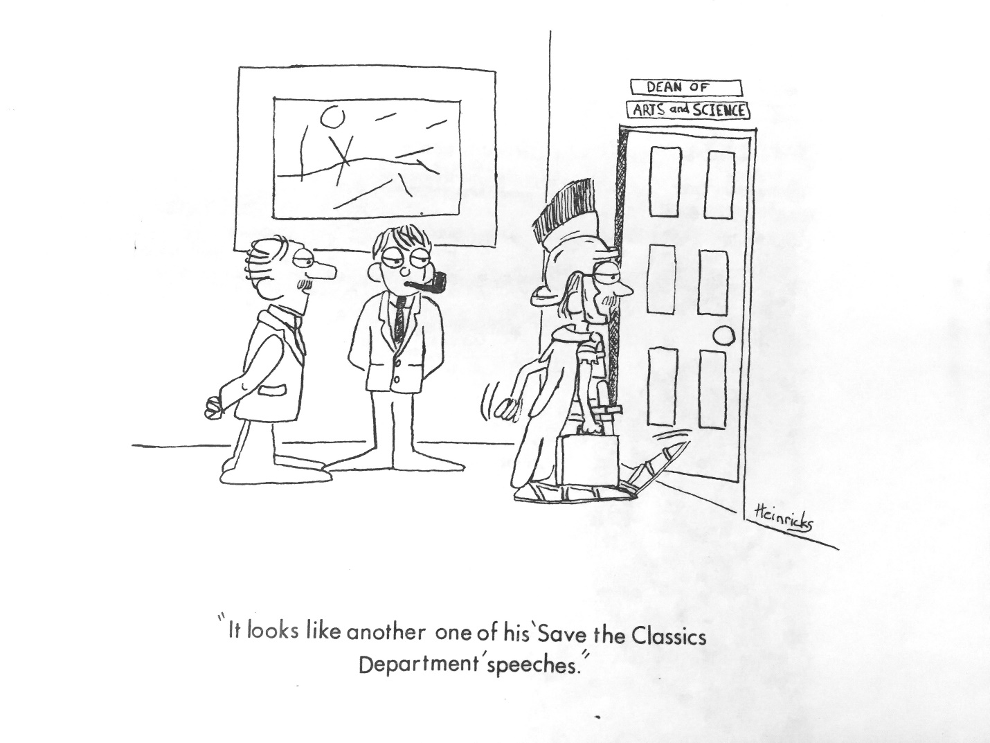*Queen’s Journal,* 1981.



*Queen’s Journal,* 1981.